# PeopleSafe - Copay Installment Payments

Payment Method for Order Placement

Changing Installment Payment Options

Reviewing Installment Payments

Copay Installments on the Portal

Frequently Asked Questions

Related Documents

**Description:** Instructions for Copay installments which allows a member to break up the total amount due for their prescription order into three equal payments.

|  |
| --- |
| Payment Method for Order Placement |

Refer to [Copay Installment Client List (43485)](https://thesource.cvshealth.com/nuxeo/thesource/#!/view?docid=4cdd6402-0ee1-42bc-9125-c5f7ab8302a2) for client(s) that are participating in the Copay Installment Payments program.

**Note:** If enrolling prescriptions in the [Auto Refill Program (ARP) (022387)](https://thesource.cvshealth.com/nuxeo/thesource/#!/view?docid=89a5f1e4-2fea-404a-a5f8-6e50549eb3de) through the Order Placement screen, copay installment payments cannot be selected. For the member to have installment payments, they will need to call into Customer Care for every refill.

Perform the steps below:

|  |  |  |
| --- | --- | --- |
| **Step** | **Action** | |
| **1** | Perform the appropriate process to place the order. Refer to:   * [Prescription (Rx) Refill/Renewal (Order Placement) (004628)](https://thesource.cvshealth.com/nuxeo/thesource/#!/view?docid=932f2f09-4581-4c2c-861d-5145ad7ab97a) * [Obtaining a New Prescription (Rx) for the Member (058827)](https://thesource.cvshealth.com/nuxeo/thesource/#!/view?docid=a1443f4f-499e-442c-be11-fd2b207bf86c) | |
| **2** | Determine if the caller would like to use the installment payment option.  Representatives should not proactively offer the installment payment option. It is always preferable to obtain full payment for the order. This option should be utilized if the member expresses that they are unable to pay the full price for their order or are becoming escalated about the cost of their prescriptions. | |
| **If…** | **Then…** |
| Yes | Proceed to the next step. |
| No | Proceed with the call according to standard processes. |
| **3** | Select the **Installment Payment** option from the Payment dropdown list: | |
| **4** | Verify the member has a default payment method on file. | |
| **If…** | **Then…** |
| Yes | Select **Installment Payment** option and **charge payment**. |
| No | Add default payment method.  Member must provide default payment method for installment payments. |
| **5** | Advise the member:  Your default payment method will be billed in 3 monthly payments. Each payment will be in the amount of $XX.XX. The first payment will be charged soon after your prescription order is shipped. The second payment will be charged 30 days after the first payment. The third, final payment will be charged 30 days after the second payment. There is no extra cost for this 3-month payment service. | |
| **6** | Click **Charge Payment**.   * If requested, provide the order confirmation number to the caller. | |
| **7** | Close the call according to standard processes. | |

Top of the Document

|  |
| --- |
| Changing Installment Payment Options |

 Installment plans are available at the time an order is placed and on the order status screen. Refer to [Payment Change Payment Method for an Open Order (025593)](https://thesource.cvshealth.com/nuxeo/thesource/#!/view?docid=47bdca4c-e5e7-4887-856d-ff34db37dfc2) if the member changes his/her preference and would like to pay for the entire order at one time.

Perform the steps below if a member requests early pay-off or cancellation of Installment Payment:

|  |  |  |
| --- | --- | --- |
| **Step** | **Action** | |
| **1** | Review the order transaction history and verify there are remaining installment payments. | |
| **2** | Verify the member has a default payment method on file. | |
| **If…** | **Then…** |
| Yes | Proceed to the next step. |
| No | Add default payment method.  Member must provide default payment method for installment payments. |
| **3** | Warm transfer the call to the [Senior Team (016311)](https://thesource.cvshealth.com/nuxeo/thesource/#!/view?docid=9eef064d-c7d7-42f7-9026-1497496b4d51). | |

Top of the Document

|  |
| --- |
| Reviewing Installment Payments |

To review a transaction that was completed via installment payment, access the **Transaction History** screen. The payment will display as follows:

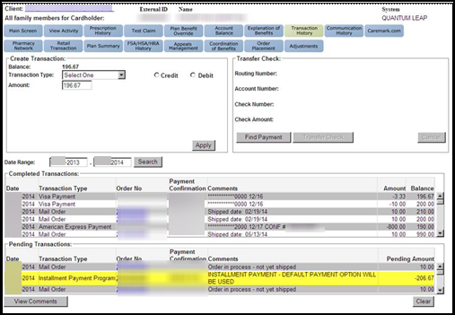

Click on the **Order Number** of the Installment Payment Program transaction type and click **Order Level Comments**. The payment installment information will display as follows:

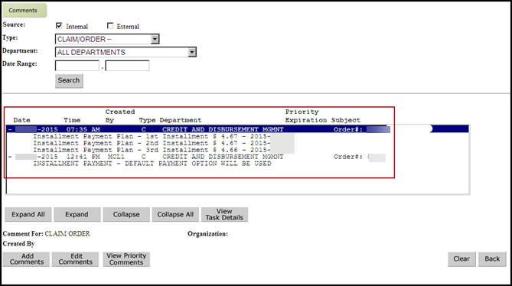

Top of the Document

|  |
| --- |
| Copay Installments on the Portal |

This functionality will also be available on Caremark.com for clients who have opted into the program. Members are able to select this as a payment method when ordering prescriptions online by performing the following steps when checking out:

|  |  |
| --- | --- |
| **Step** | **Action** |
| **1** | Click **Set up Now** hyperlink.    **Result:** Pop up screen displays. |
| **2** | Select radio box adjacent to proper account to charge. |
| **3** | Click on **Change Default Payment Method**. |

**Reminder: FSA, HSA, or HRA cards are not accepted for installment payments**. If the member selected an FSA/HRA/HSA card for his/her default payment method, a message box displays to inform the member that their plan allows for installment payment if their default payment method is changed.

 The member must select another Default Payment Option or add a new Payment Option and make it the Default account to charge.

Top of the Document

|  |
| --- |
| Frequently Asked Questions |

Utilize as appropriate:

|  |  |
| --- | --- |
| **Question** | **Answer** |
| **What if the member changes their default payment method after the first of the three payments has been deducted? Which credit card will be charged for the remaining two payments?** | The remaining payments will be charged to the default payment method on file at the time the payments are charged. |
| **What happens if they have multiple Rx orders on that occur on different dates?** | Separate orders will have separate series of installment payments. |
| **If I have multiple orders on an installment plan, can they be set up so that all are due on the same date of the month?** | No. |
| **What if the member requests installment payments for an order that has already shipped?** | Installment payments cannot be added to orders previously shipped without an installment payment plan attached. Installment payments must be added when the order is placed or before the order reaches Ready Label status. |
| **Will there be a Balance due if only one payment has been made?** | A balance due amount will not show on the member’s account unless one of the installment payments is declined. |
| **What occurs if a member has an outstanding balance due and then selects this payment method for a new order?** | Both amounts will be combined and split into three separate, equal installment payments.  **Example:** Balance due: $100, New Order Amount $200 = 100+200 = $300  Payment Amount Charged to Member will be: $100 in three separate payments. |
| **Only specific clients have been approved for the installment payment program. How will we know which members will have this option to select on the portal?** | The portal option is driven by the client code. The installment copay option will only display for those members who have this benefit. |
| **If one order ships today and another ships 5 days from now. Will there be one series of installment payments?** | No, there will be two separate installment payment plans with six total transactions. |
| **How were clients chosen? Will we be offering installment copay to other clients in the future?** | These clients were chosen based on size and client desire for alternatives. This offering is currently limited but could be rolled out to other clients in the future. |
| **Will this place a HOLD on a member’s debit card for the entire amount or just each installment?** | The installments will be charged 30 days apart.    **Example:** For a 90-day refill placed on May 1st that costs $30, there will be a first charge on May 2nd for $10, then on June 2nd another $10 charge and then a final $10 charge on July 2nd. There will only be a hold for each installment payment when it is charged. |
| **What happens when a member doesn’t have the funds available for the 2nd/3rd copay?** | If an installment payment fails for any reason, the amount is returned to the account as a balance owed for collection. |
| **When selecting “Installment Payments” does that automatically go to the default card?** | Yes. |
| **How does a previous balance reflect if it is included in an order where the member has selected “installment” payments?** | **Example:** Member places a 90 refill that costs $20 and there is a previous balance of $10. The previous balance will be added to the current order amount, for a total of $30. Then the installment payment will divide the payments into 3 equal payments of $10. |
| **Can a member use an FSA, HSA or HRA card for installment payments?** | FSA, HSA or HRA cards will not be allowed with installment payment programs due to IRS requirements regarding the processing of these card payments. |
| **What if the copay is extremely high (Example: Over $600)? You could potentially have 3 installment payments of $200 each. Will that flag the “high copay” warning, divert the order and force a call to the member to approve the payment?** | The high co-pay divert would occur for the total order charge at the time the order is processed. The individual installment payments will not initiate an additional call(s) to the member. |

Top of the Document

|  |
| --- |
| Related Documents |

**Parent Document:** [Customer Care Internal and External Call Handling (CALL-0049)](https://policy.corp.cvscaremark.com/pnp/faces/DocRenderer?documentId=CALL-0049)

[Customer Care Abbreviations, Definitions and Terms (017428)](https://thesource.cvshealth.com/nuxeo/thesource/#!/view?docid=c1f1028b-e42c-4b4f-a4cf-cc0b42c91606)

Top of the Document

Not to Be Reproduced or Disclosed to Others without Prior Written Approval

**ELECTRONIC DATA = OFFICIAL VERSION - PAPER COPY - INFORMATIONAL ONLY**